R.SENTHIL MURUGAN

WEEK-1
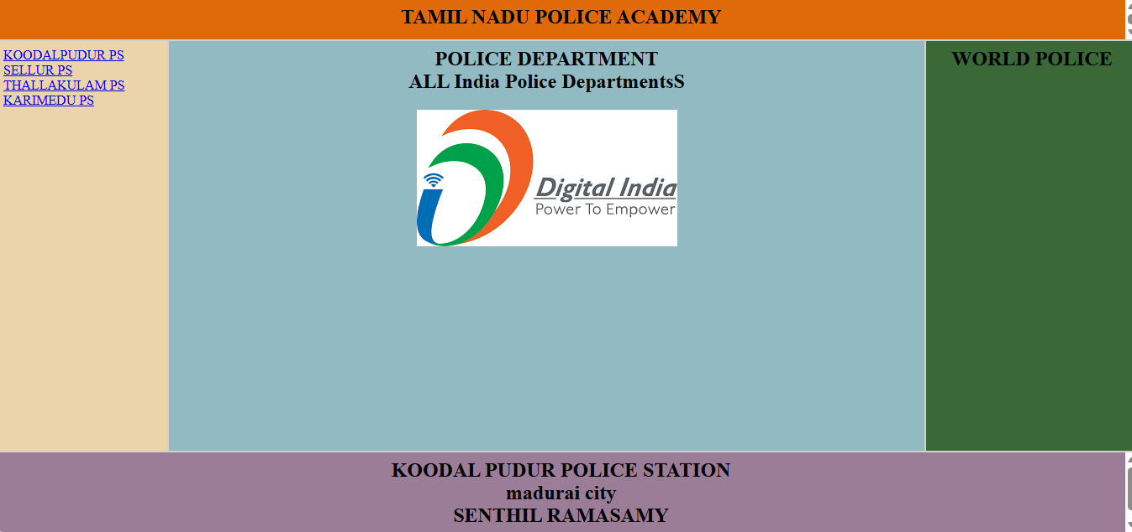

HTML is used to create the structure of the webpage shown in the image.
The title “Tamil Nadu Police Academy” is made using heading tags like <h1>.
The police station names on the left are created using anchor <a> tags for links.
The Digital India logo is displayed using the <img> tag.
Different sections of the page are arranged using <div> tags and styled with CSS.

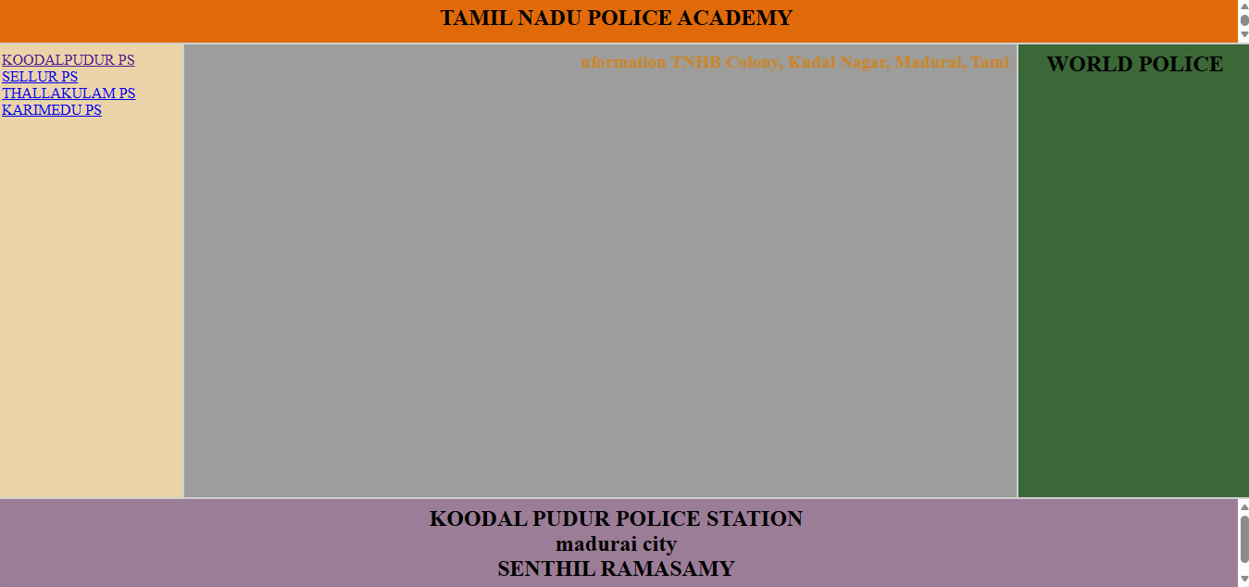

The <img> tag for the Digital India logo has been removed from the HTML.
A new text line (address information) was added using a heading or <p> tag in the center section.
The middle <div> background remains, but now it only displays text instead of an image.

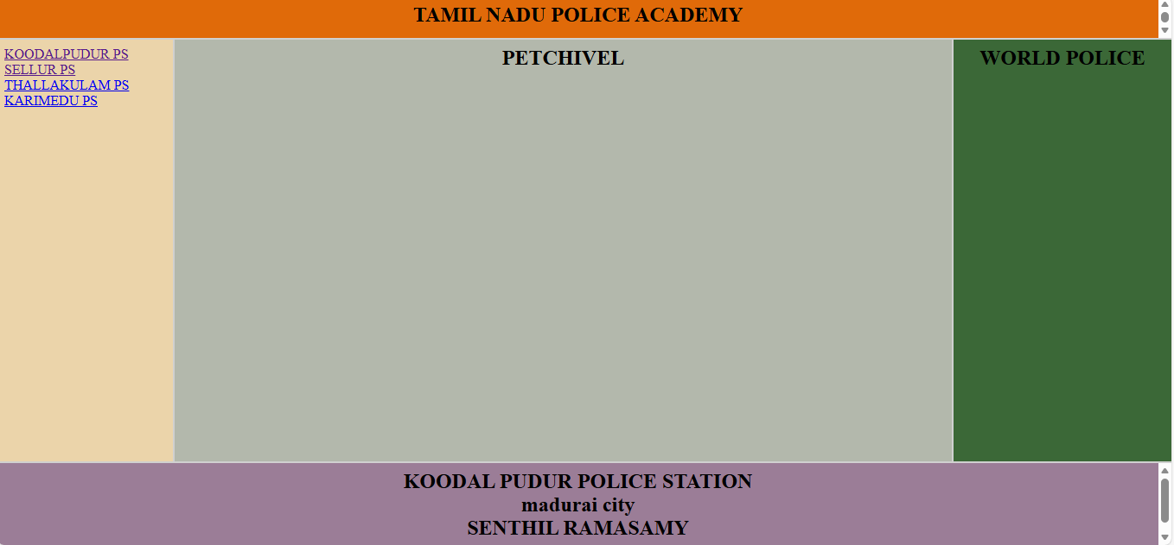

The middle <div> background remains, but now it only displays text instead of an image.

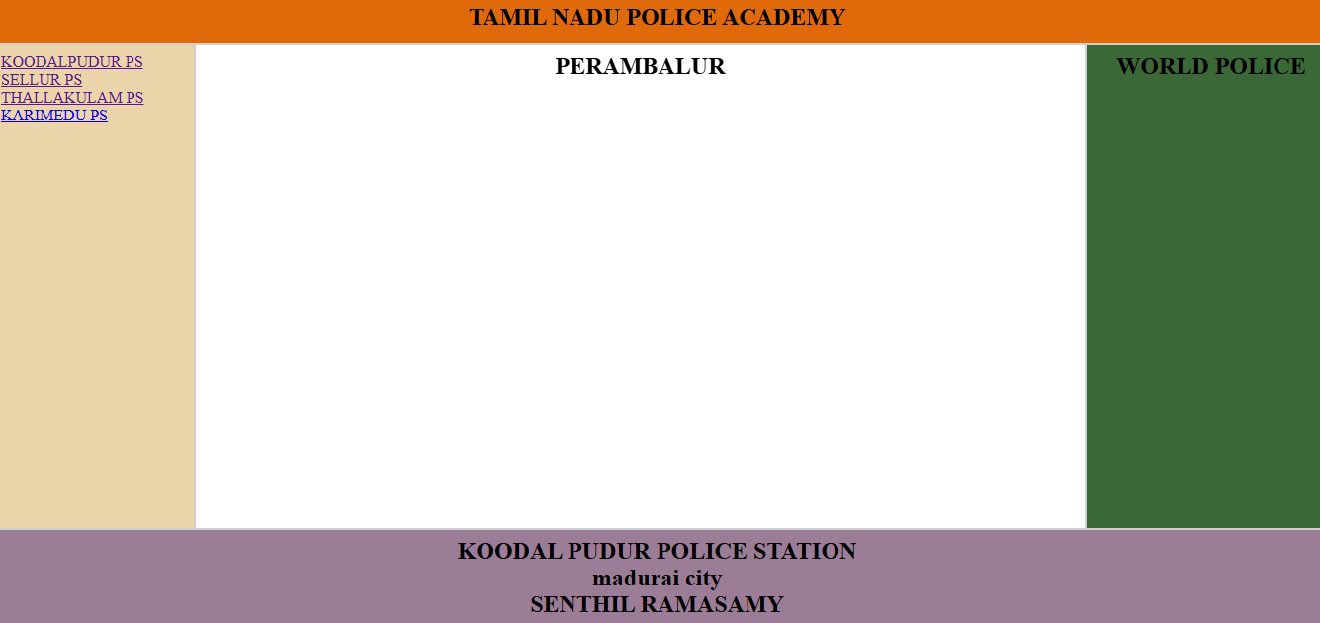

The middle <div> background remains, but now it only displays text instead of an image.
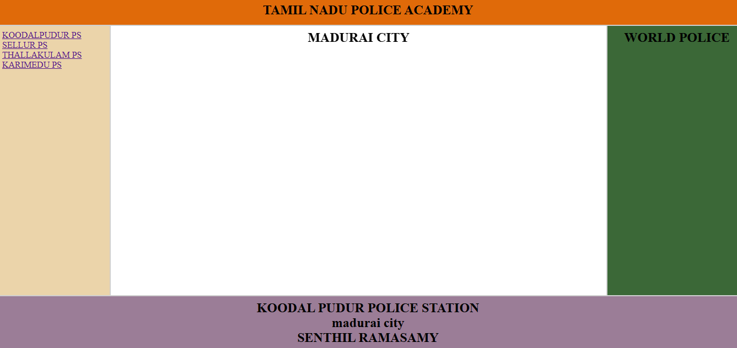

The middle <div> background remains, but now it only displays text instead of an image.

